**Understanding the effect of prior distributions for hierarchical variance parameters in the Ricker spawner-recruit model**

Prepared for the Limit Reference Point Technical Working Group (June 29, 2020)

Purpose:

This note has been prepared to clarify the shape of the “noninformative” variance prior distributions being considered for our LRP analysis of Interior Fraser Coho, as well as the impact of these distributions on estimates of CU-level Ricker productivity parameters, Sgen, and aggregate Limit Reference Points (LRPs) in our integrated LRP modelling framework. It has been written to address confusion that emerged at the TWG meeting #5 on June 24, 2020.

Model Formulation:

The Ricker model being considered as part of the Integrated LRP estimation framework for Interior Fraser Coho has the following form:

$${\hat{R}}_{i, a, t}=P_{i, a, t-a}{ S}_{i, t-a}{ e}^{α_{i}+ γ\operatorname{Ln}\left(M_{t-1}\right)-β_{i}S_{i, t-a}}$$

where:

${\hat{R}}_{i, a, t}$ = the predicted number of natural origin recruits returning in year t of age a produced by escapement in brood year t-a

$P_{i, a, t-a}$ = the proportion of recruitment from CU i returning at age a from brood year t-a

$S_{i, t-a}$ = spawners from CU i in brood year t – a

$α_{i}$ = productivity parameter from CU i

$γ$ = marine survival co-efficient shared among CUs

$M_{t-1}$ = marine survival for sea entry in year t – 1

$β_{i}$ = density dependence parameter for CU i

The model assumes lognormal process error on recruits-per-spawners,

$$\operatorname{Ln}\left(\frac{R_{i,by}}{S_{i,by}}\right)\sim Normal(\operatorname{Ln}\left(\frac{{\hat{R}}_{i,by}}{S_{i,by}}\right), τ_{i})$$

where, $τ_{i}$ is the estimated precision, which is the inverse of variance ($τ=1/σ^{2}$). A gamma distribution is used to create a noninformative prior distribution on $τ_{i}$, which is analogous to an inverse gamma prior on variance $σ^{2}$. (Details on the parameterization of the gamma prior are in the next section).

The model has a hierarchical structure on CU-specific productivity parameters, $α_{i}$, such that:

$α_{i} \sim Normal\left(μ_{α}, τ_{α}\right)$,

where, $μ_{α}$ and $τ_{α}$ represent the mean and precision of a hyperprior distribution describing the variation in natural-log-productivity among CUs. Prior distributions on $μ_{α}$ and $τ_{α}$ are also assumed.

Prior Specification:

The following priors were used in the Bayesian WinBUGS model used by Arbeider et al.

$$τ\sim gamma(0.01, 0.01)$$

$$μ_{α}\sim normal(μ_{∝}= 1, { τ}_{α}= 0.5)$$

$$τ_{α}\sim gamma\left(0.1,0.1\right)$$

$$γ\sim normal(μ= 0, { τ}_{γ}= 0.01)$$

Note that in WinBUGS, normal distributions are parameterized using precision ($τ$) instead of variance, where precision is the inverse of variance: $τ=1/σ^{2}$. Therefore a gamma distribution on precision is the same as an inverse gamma distribution on variance. The relationship between three levels of gamma prior on $τ$ and the associated inverse gamma prior on $σ^{2}$ is as follows:

|  |  |
| --- | --- |
| **Gamma prior on τ (or 1/σ2)**  (α= shape, β = rate) | **Inverse gamma prior on σ2**  **(**α= shape, β = scale) |
| Gamma (0.01, 0.01) | Inv.Gamma (0.01, 0.01) |
| Gamma (0.1, 0.1) | Inv.Gamma (0.1, 0.1) |
| Gamma (1, 1) | Inv.Gamma (1, 1) |

The shape of the prior distribution on the variance ( $σ^{2})$ associated with each of these three parameterizations is shown here (with the code used to produce this plot below):



> library(invgamma)

> x<-seq(0,6,by=0.001)

> plot(x, dinvgamma(x,0.01,0.01), typ="l", col="red", ylim=c(0,0.6),

+ xlim=c(0,6), ylab="Density",xlab=expression(sigma^2), lwd=2)

> lines(x, dinvgamma(x,0.1,0.1), col="blue",lty=1,lwd=2)

> lines(x, dinvgamma(x,1,1), col="steelblue2", lty=1,lwd=2)

All three distributions have the same expected value due to the increasingly longer tails as the shape and scale parameters decrease. Gamma (0.01, 0.01) is sometimes characterized as being the most noninformative of the three as it has the longest tail and the highest variance even though the bulk of the density is near zero. However, because these distributions increasingly push the variance $σ^{2}$ towards zero as the shape and scale parameters decrease, they create an increasingly smaller error distribution for the associated quantities of interest ( $\operatorname{Ln}\left(\frac{R_{i,by}}{S_{i,by}}\right)$ or $μ_{α}$). This pattern can be seen by comparing the highly skewed inv.gamma(0.01, 0.01) distribution (i.e., the gamma (0.01, 0.01) on τ; red line on plot) compared to the inv.gamma(1,1) distribution (i.e, gamma (1,1) on τ; light blue line on plot).

Sensitivity Analysis

For the purpose of using Interior Fraser Coho as a case study to evaluate LPR estimation methods, we tested the sensitivity of estimated parameters to prior distributions. In this note, we focus on the effect of prior distributions for variance the parameters because this is where were saw the largest sensitivity.

We used the following nine scenarios to test the sensitivity α, Sgen, and LRP estimates to prior distributions on variance:

|  |  |  |
| --- | --- | --- |
| **Scenario** | **Prior on τ** | **Prior on τα** |
| 1 | gamma (0.01, 0.01) | gamma (0.01, 0.01) |
| 2 | gamma (0.01, 0.01) | gamma (0.1, 0.1) |
| 3 | gamma (0.01, 0.01) | gamma (1, 1) |
| 4 | gamma (0.1, 0.1) | gamma (0.01, 0.01) |
| 5 | gamma (0.1, 0.1) | gamma (0.1, 0.1) |
| 6 | gamma (0.1, 0.1) | gamma (1, 1) |
| 7 | gamma (1, 0.1) | gamma (0.01, 0.01) |
| 8 | gamma (1, 0.1) | gamma (0.1, 0.1) |
| 9 | gamma (1, 0.1) | gamma (1, 1) |

Our results are shown in Figures 1 – 3.

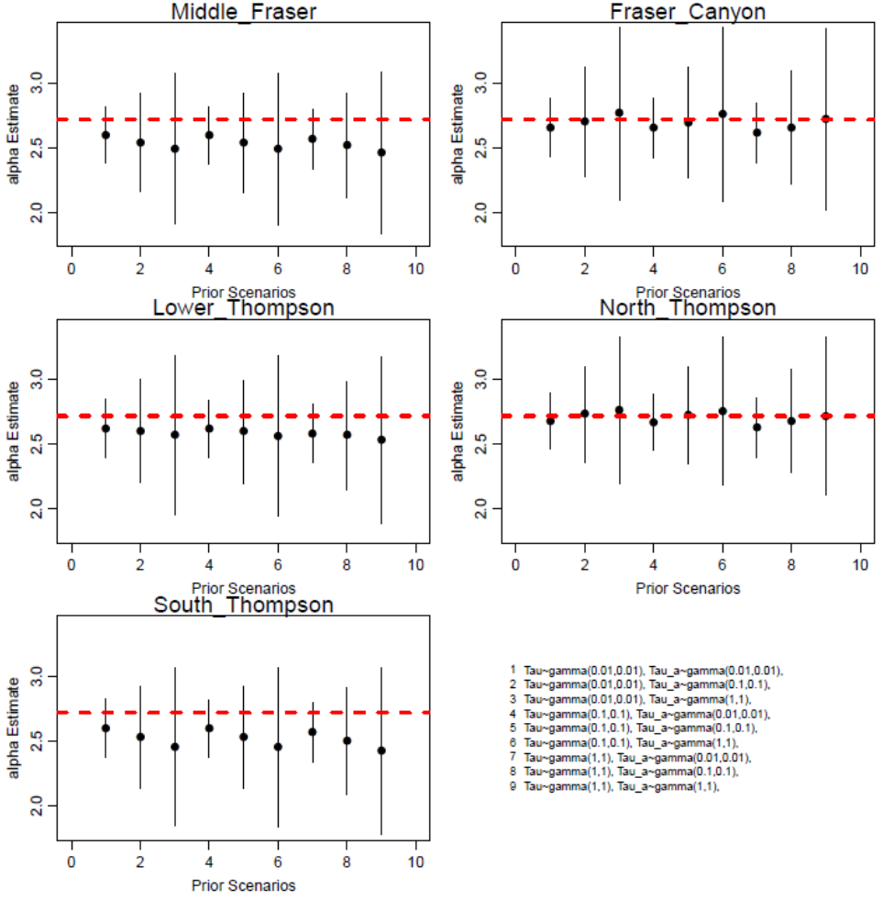

*Figure 1. CU-level alpha ($α_{i}$) estimates from each of the nine sensitivity analysis scenarios considered. Error bars show the 95% confidence intervals. Red dashed lines show the mean of the alpha hyperprior.*

*Discussion of Results – Figure 1:*

* The effect of the prior assumption on $τ_{α}$ had a larger effect on CU-level $α_{i}$ than the prior assumption on $τ$. This is evident from, for example, the larger difference between scenarios 1-3 than between scenarios 3, 6, and 9.
* The smaller shape and rate parameters in the gamma distribution (e.g., gamma (0.01, 0.01)) acted to make CU-level alpha estimates more similar to each other by shrinking them towards the µα. For the Middle Fraser, Lower Thompson, and South Thompson CUs, this shrinkage acted to pull $α_{i}$ upwards as the gamma shape and rate parameters decreased from 1,1 (scenario 3) to 0.1, 0.1 (scenario 2) to 0,01, 0.01 (scenario 1). In other words, gamma (0.01, 0.01) has the largest shrinkage. The opposite pattern is apparent when looking at the Fraser Canyon and North Thompson CUs. The $α_{i}$ parameters get pulled down towards µα at gamma (0.01, 0.01).

🡪 Thus, the gamma (0.01, 0.01) prior acts to make all CUs have more similar estimates of productivity, while the gamma (1,1) prior allows for more variation in productivity among CUs. Thus, out of the three distributions considered, the gamma (0.01, 0.01) imposes the most information on CU-level values of alpha because it forces $α_{i}$ to be closer to µα.

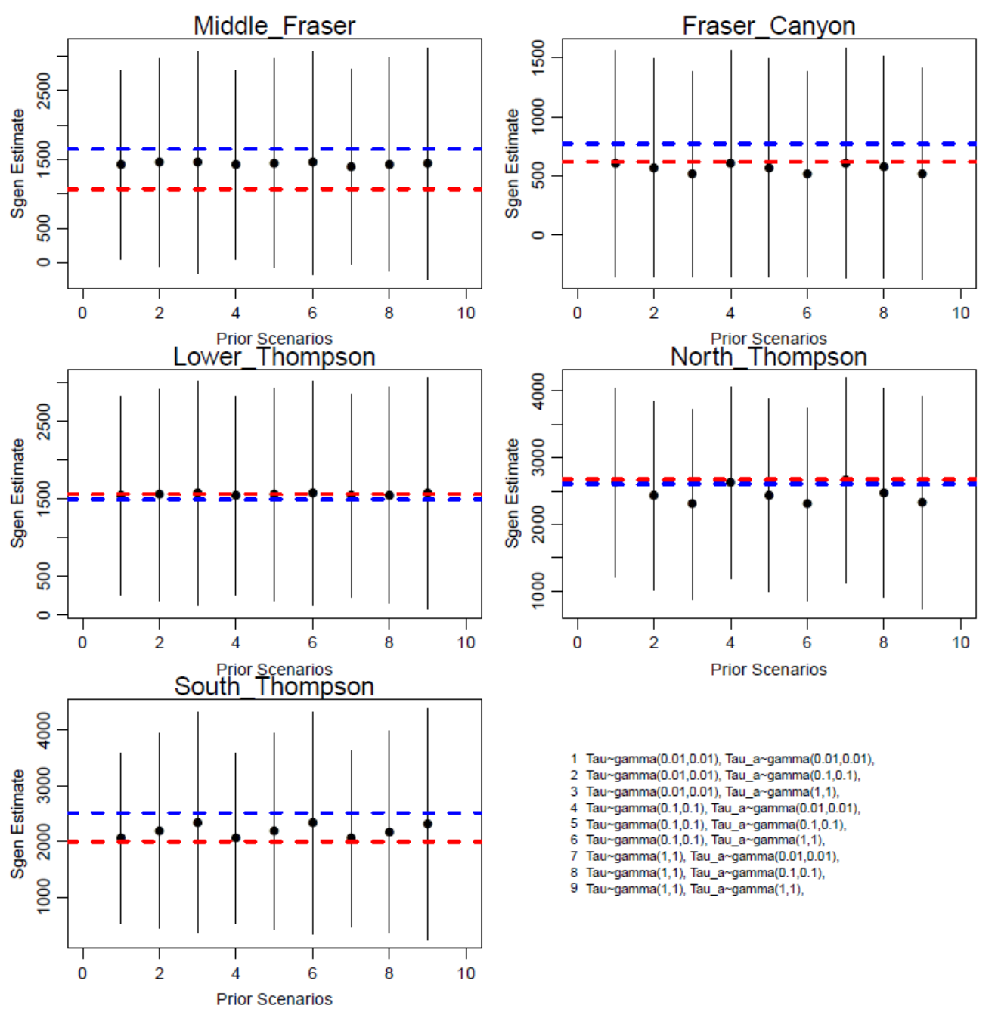

*Figure 2. CU-level Sgen estimates from each of the nine sensitivity analysis scenarios considered. Error bars show the 95% confidence levels. Horizontal blue dashed lines shows the mean estimates reported from the 2015 WSP Integrated Status Assessment (DFO 2015) while red dashed lines show the values reported by Korman et al. 2019.*

*Discussion of Results – Figure 2:*

* These results correspond to those of Figure 1, with estimates of Sgen being most sensitive to the prior assumption on $τ_{α}$. Notable differences in Sgen are only seen for 3 out of 5 CUs (South Thompson, Fraser Canyon, North Thompson).

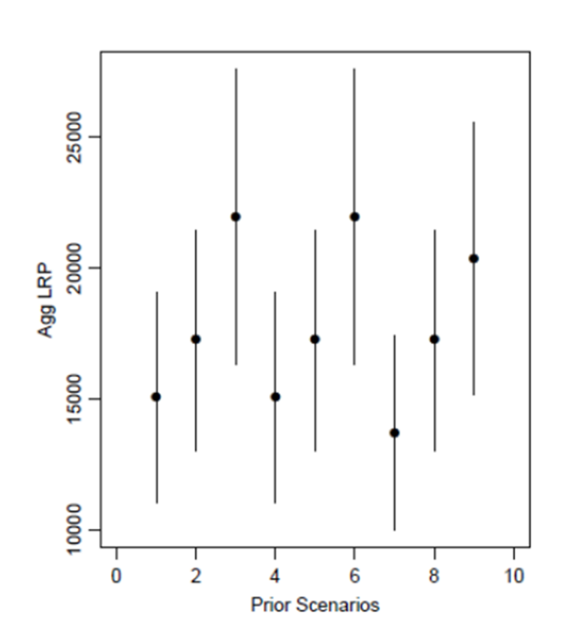

*Figure 3. Aggregate LRP estimates for each of the nine sensitivity analysis scenarios considered when LRPs are estimates using a binomial LRP model with a threshold proportion of 95% of CUs > Sgen. Error bars show the 95% confidence levels.*

*Discussion of Results – Figure 3:*

* While the differences in Sgen among scenarios about the prior distribution on $τ_{α}$ appeared small in Figure 2 (i.e., only a few hundred fish), these differences had a relatively large effect on the estimated aggregate LRP. This is due to CU-level escapements in several years being close to Sgen, which affects the proportion of CU’s observed to be above or below Sgen. These changes in proportions can have relatively large effects on the logistic model fits used to estimate LRPs.
* While the effect of the $τ_{α}$ prior on LRP values is most apparent in these plots, there is also a decrease in LRP as $τ$ moves from gamma(0.1, 0.1) to gamma (1, 1). This decrease can be seen when comparing scenario 4 to scenario 7, or when comparing scenario 6 to scenario 9. This decrease is a result of slight shifts in Sgen that are too small to see in Figure 2, but that affect the level of certainty is assessments of annual stock status relative to Sgen for some CUs, which in turn affects the fit of the LRP logistic regression model.

Gelman 2006 (<http://www.stat.columbia.edu/~gelman/research/published/taumain.pdf>)

* Gelman (2006) has previously shown that the choice of noninformative gamma priors can have a large effect on posterior model inferences, especially when the number of groups is small (which is the case here with only 5 CUs) and the group-level variance is close to zero (also the case here). They noted that despite the common practice of using gamma (0.001, 0.001) as an uninformative prior on hierarchical variance parameters, these values lead to distributions that cannot be considered noninformative and should be avoided when modelling hierarchical variance. Instead, Gelman (2006) recommended starting with noninformative uniform prior distributions of variance parameters.